**Cross-database joins**

Open the file Sales 2016.xlsx. Then click on “Add” on the upper left hand corner. Choose “text” and open the file “Products 2016.csv”.

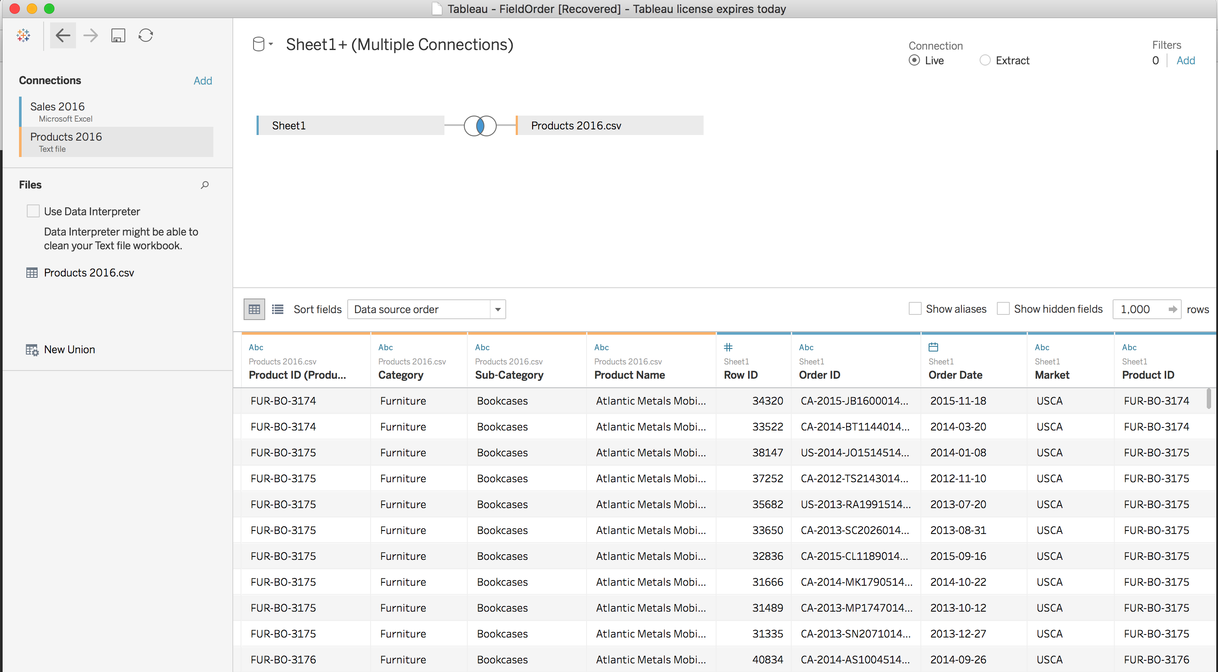

Once you add the second file (products) Tableau will automatically assume that you want to do an “inner join”. Click on the two intersected circle and change to “left join”. This will join both tables by “Product ID” and it will keep all the rows of the left table (Sales 2016) and add columns from the right table (Products 2016). If a product ID in the left table does not exist in the right table it will provide “null” values for the columns of the left table.

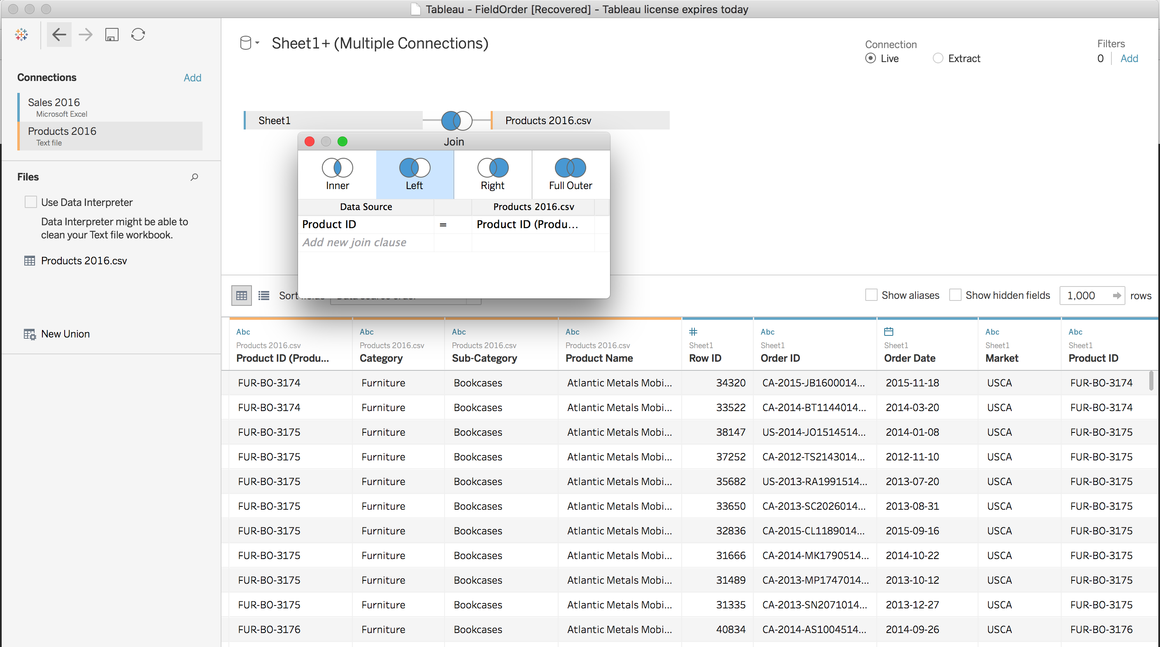

Rename the sheet “Join-Exercise” and create a graph that illustrates annual sales broken down by category and sub-category.

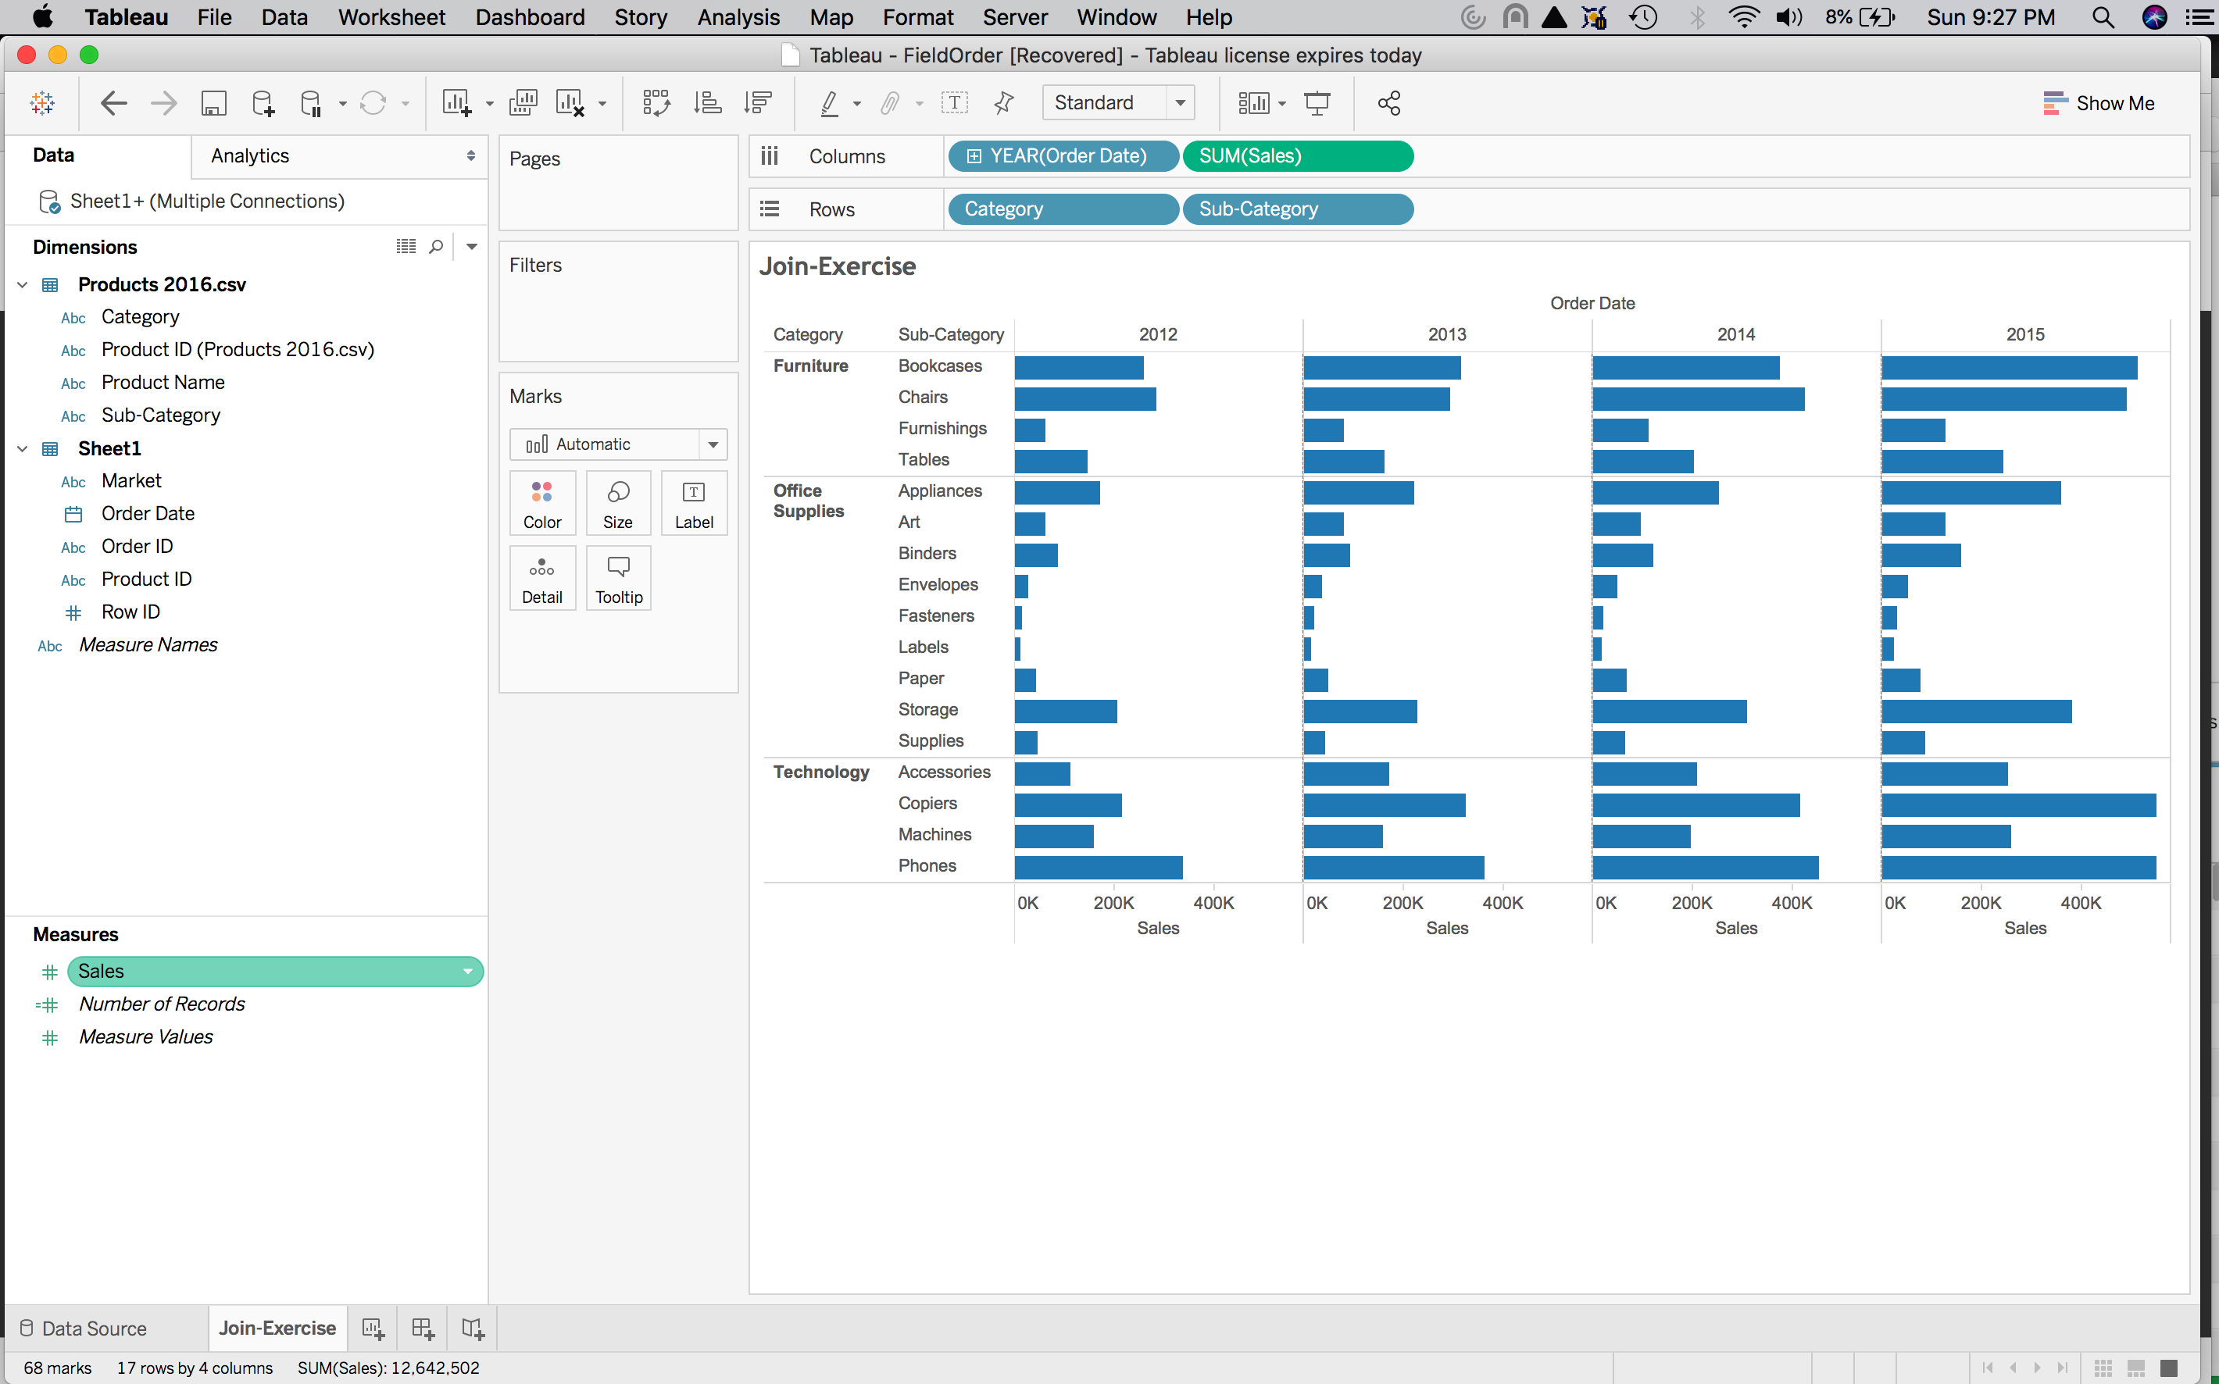

Open the files “Coffee Chain” and “Office City”. Now you need to find to find two fields that have common attributes. Territory in “Office Chain” and Region in “Coffee Chain” are such fields. They both have “Central”, “East” and “South” as possible values. So, you can blend both files based on these two fields

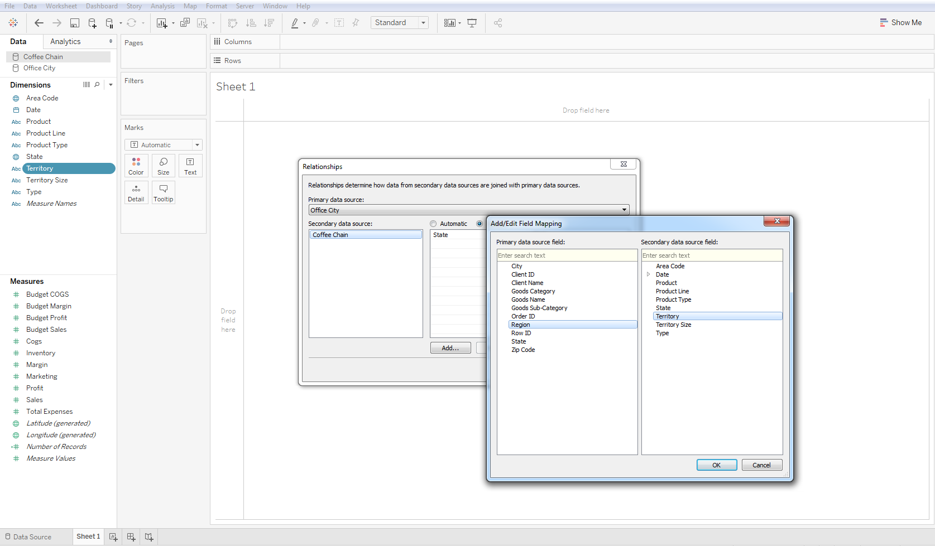

Notice the chain in front of “State”. It means that it’s the main variable/key linking the two tables, and the second chain (it was grey and broken and I activated it so it turned red) also means that it was key used to link the two tables. The blue check mark on the right of “Office City” means that it’s the primary table/source that was used. Notice that in the second chart that not all States are present.

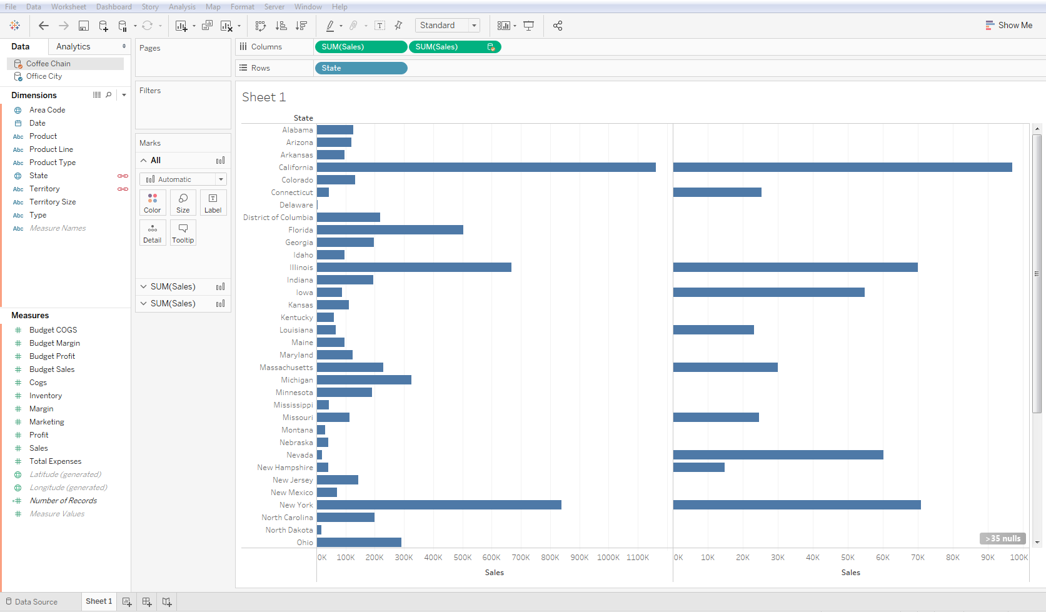

Now if you create a new sheet and start over the relation that was created in the previous sheet is not carried over (primary table and secondary table). If you take Coffee Chain as the primary table (by clicking on it) and then drag Sales and State as shown below you’ll see only half of the States. That’s because “Coffee Chains” has fewer States than “Office City”.

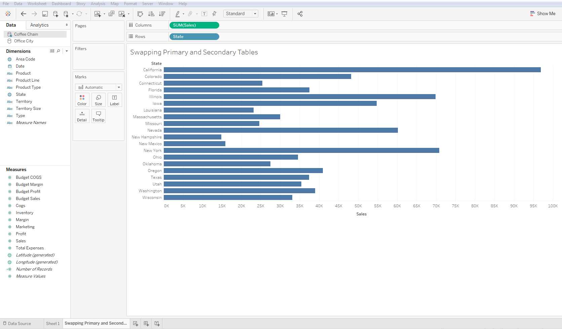

If you also drag Sales from “Office City” you will get only States in “Office City” that are also in “Coffee Chain”

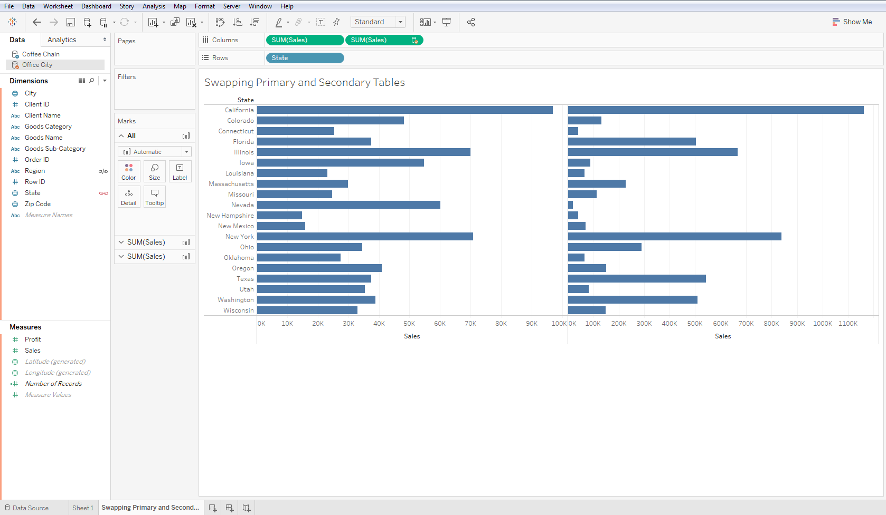

**More on Data Blending**

Right click on the white left panel and create a new calculation. Drag Sales from each table. The second item in the addition has the name of the table in it just to be able to distinguish which field is coming from which table. Notice that Sales from “Office City is aggregated and Sales from the other table are not aggregated. Add SUM to the first part (like so “SUM[Sales]”) and keep the second part unchanged so you can add them up.

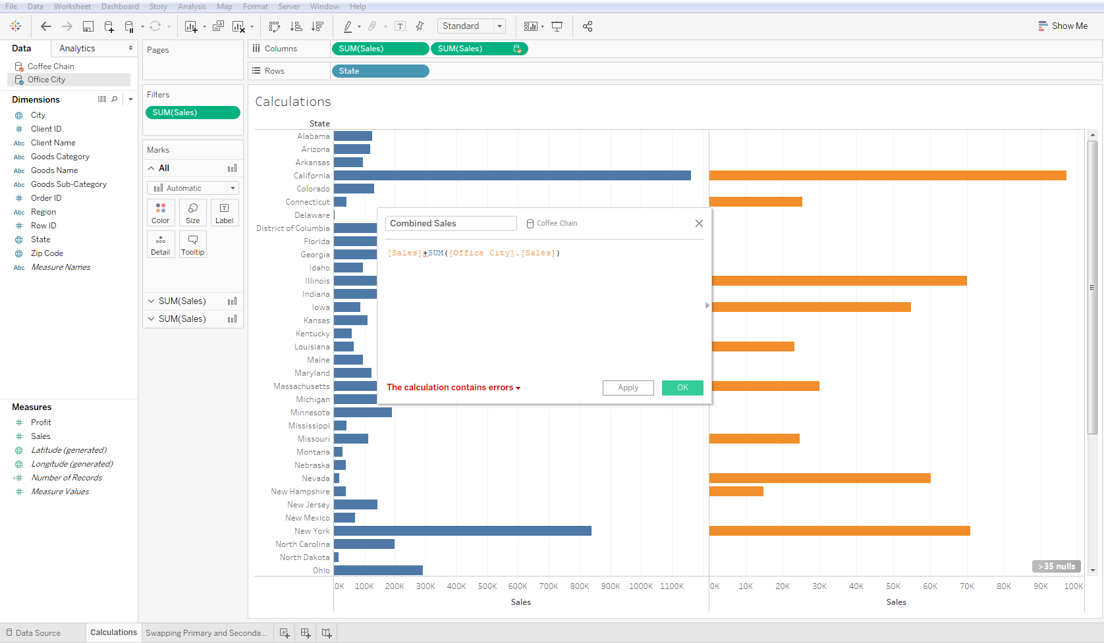

Now drag “Combined Sales” into Columns and notice that there are no combined sales for some States. That is because some States don’t exist in the second table and therefore their sums are zeros. Tableau count value+null as null. In order to change that look at the next step.

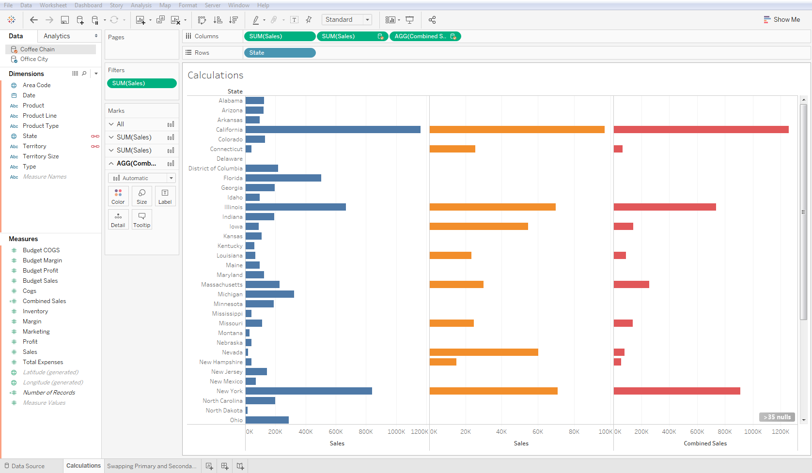

You need to go back to “Combined Sales” and modify Sales in “Office City” by applying the “Zero Null” function, which converts nulls to zeros because we know that our null values mean zero sales in those States. Now the “Combined Sales” are calculated for all States.

